EET 200

PROTEL SIMULATION LABORATORY
09/24/03

GOAL:
- To learn the basics of schematic simulation with Protel.

ASSIGNMENTS:
- Multivibrator (with instructor)
- Push-Pull Amplifier (submit to Dan Kohn)

MULTIVIBRATOR
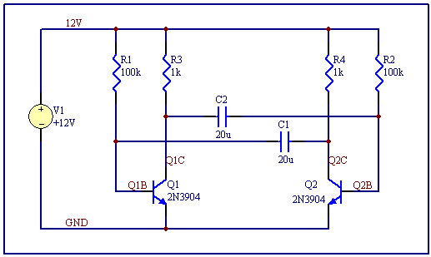

PARTS: R1, R2, R3, R4 RES *NOTE: must only use Sim Library!
C2, C2 CAP
Q1, Q2 2N3904
V1 +12V source

General Simulation Steps:
1st: Draw schematic and label all attributes.
2nd: Assign appropriate net labels for measuring.
3rd: Run ERC
4th: Simulate → Setup…
5th Setup for appropriate analysis; choose active signals
6th: Run Analysis
7th: Set up waveforms with appropriate scaling, cursors, and designation symbols

PUSH-PULL AMPLIFIER

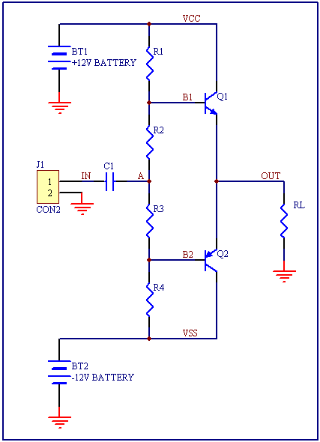

PARTS: R1 = 100k *Remember to only use Sim Library!
R2 = 10k
R3 = 10k
R4 = 100k
RL = 200
C1 = 1.26u
Q1 = 2N2219A, Q2 = 2N2905A
Net Labels: VCC, VSS, IN, OUT, A, B1, B2
CON2 = VSIN (Sinusoidal Voltage Source) @1 (AC), 1 (Amplitude), 1k (freq.)
BT1 = +12V Simulation Source (Label it VCC)
BT2 = -12V Simulation Source (Label it VSS)

Lab requirements:
- Name DDB as: Your Initials-Sim.ddb
- Name the schematic file as Push-Pull.sch
- Schematic drawn and labeled appropriately with properly labeled Title Block
- ERC run
- Simulation Setup as follows:
Transient/Fourier Analysis - ON
    - CALCULATE Stop time, Start time, and Max Step
    - Stop Time = 1 / lowest frequency source * Cycles Displayed
    - Step Time = (1/ lowest frequency source) / Points per Cycle
    - Max Step = Step Time

AC Small Signal – ON
- Start Frequency – 1kHz
- Stop Frequency – 10kHz
- Test points – 50

Operating Point Analysis – ON

Collect Data For: Node Voltage, Supply and Device Current

Active Signals: B1, B2, IN, OUT

- Run Analysis
- For Transient Analysis: View B1, B2, IN, OUT as a single cell with designation symbols active
- For AC Analysis: View B1, B2, IN, OUT as separate cells with data points active
- For Transient Analysis: Place measurement cursors for IN at 0.500ms; OUT at 1.000ms.
- For AC Analysis: Place measurement cursors for IN at 2kHz; OUT at 4kHz.
- For Operating Point: Display B1, B2, IN, OUT

*Submit DDB file to Dan Kohn. (http://ceetusm.com/~EET200/)

